Assignment 3

Q1. Given two NxN matrices A and B, Find the time efficiency of the definition-based algorithm for computing their product C= AB. By definition, C is an NxN matrix whose elements are computed as the scalar (dot) products of the rows of matrix A and the columns of matrix B.

Ans. 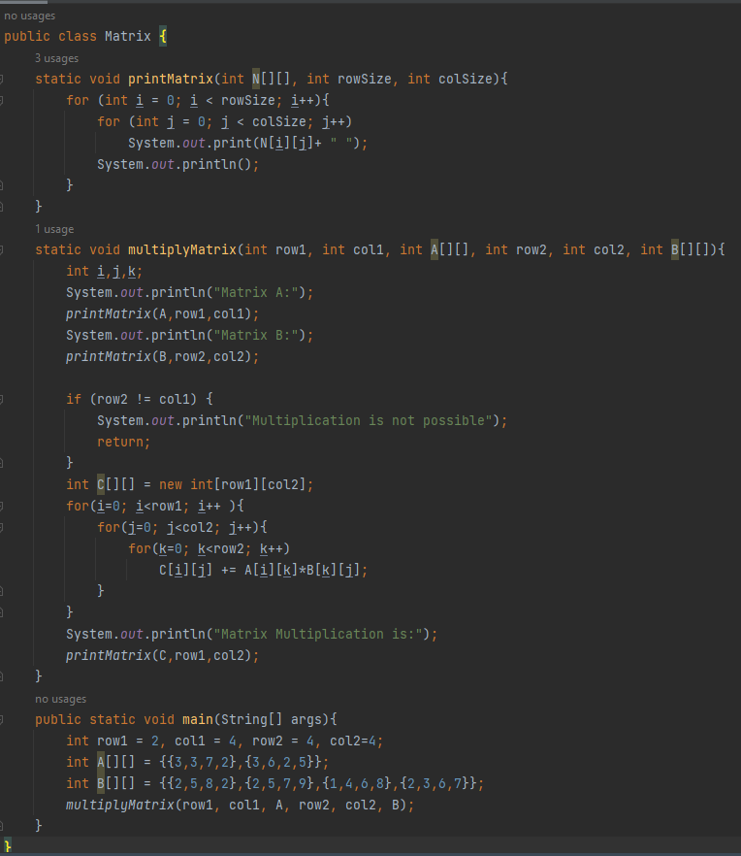Output:

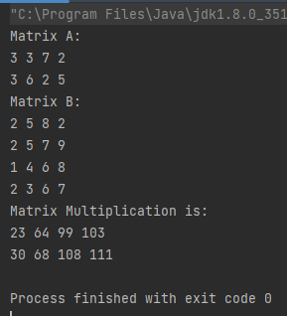

Q2. Analyse the matrix multiplication.

Ans. The total time complexity will be O(n^3) because we have 3 loops and each loop will run n times which makes the total n^3. Hence, the time required to run this algorithm will be O(n^3).